# The Assignment

We have received the attached csv file from a customer; a commodity trading company. This is a new customer who signed up to use our CTRM product Agiblocks. The customer has an ERP system where he manages his trading related activity. The ERP system is very old and can only export all data in it to a csv file.

The customer asked us to import counter party (Companies who this customer does trading with) from the csv file to Agiblock. Currently Agiblock does not have any import functionality. We have to implement data import from csv file and in future we might need to support various different file format (for example: xml, excel).

The file the customer has sent only contains a subset of all counter party in the ERP system. The full list of all counter party is over 10 MB in size and it should be possible to import this complete file.

Agiblock stores counter party information in this following table:

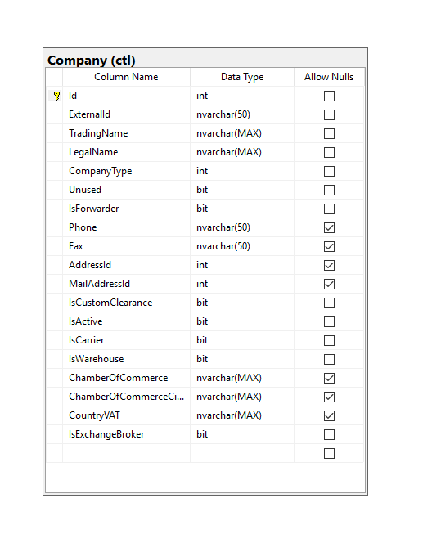

## Build an MVC web application with the following features

• The customer has to be able to import the csv file using the web interface.

• Analyze the data in the csv file and create a logical data model based upon your analysis.

• Create an overview page with all the counter party from the imported csv(s) listed.

Your implementation should follow the SOLID design principles. In case of a second interview you will be asked to explain how you have applied these principles.

Nice to have

* Implement the solution using TDD/BDD methodology.
* Use of Angular/React
* Use Entity Framework
* Tests to verify the application works correctly